APRIL 11 CLASS FIRST CLASS DOCKER

Example diagram :

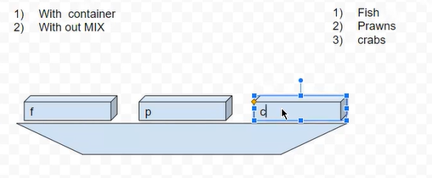

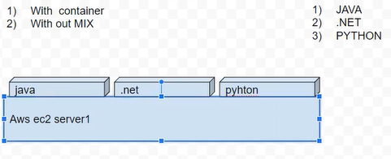

Live example :

Create EC2 instance

Security group : All traffic

Copy ssh link

Open git bash $ paste ssh link

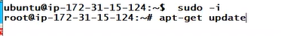

<https://get.docker.com/>

$ curl -fsSL https://get.docker.com -o get-docker.sh



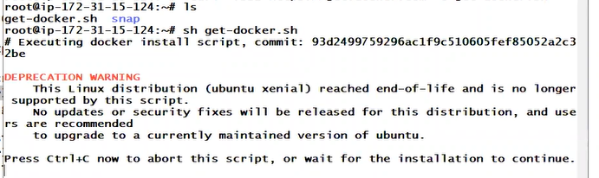

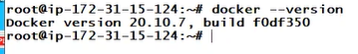

NGINX CONTENER INSTALL COMMAND



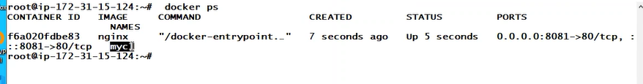

JENKINS CONTENER INSTALL COMMAND



Tomcat CONTENER INSTALL COMMAND



---------------------------------------



-DELETE ALL DOCKERS CONTAINERS



APRIL 12 CLASS

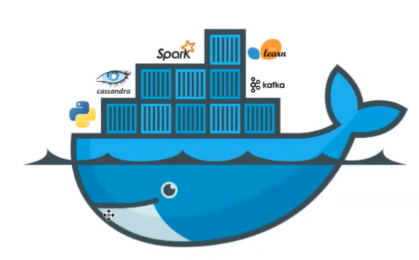

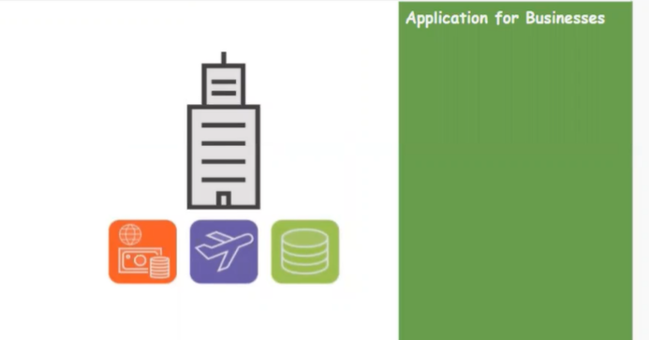

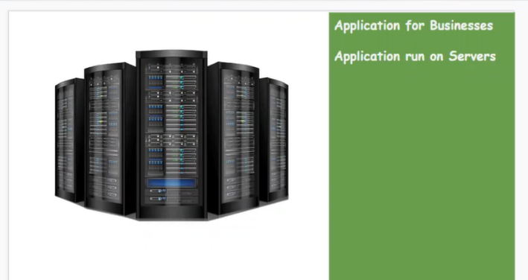

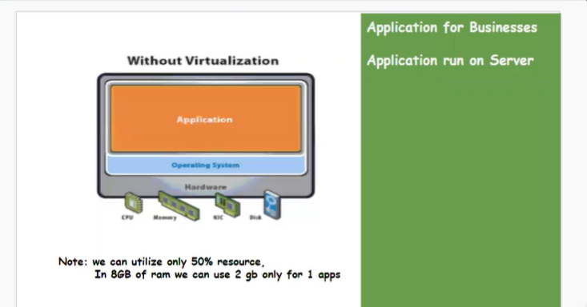

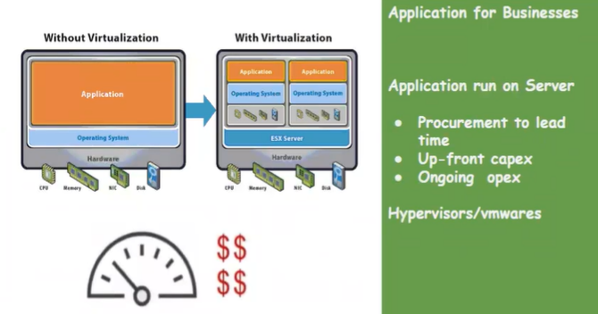

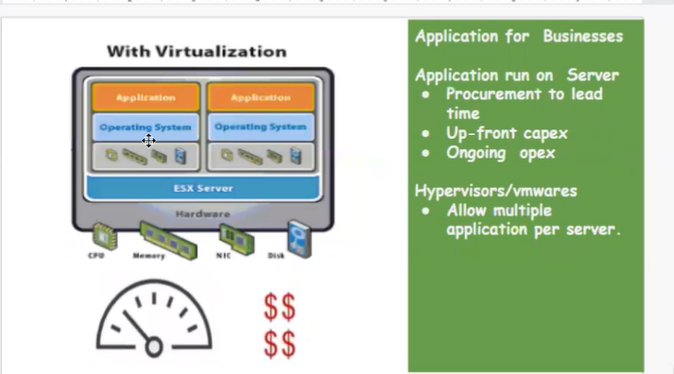

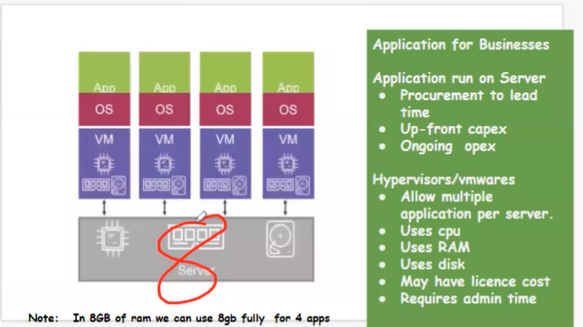

CONTAINER TECHNOLOGY Operating system is not required

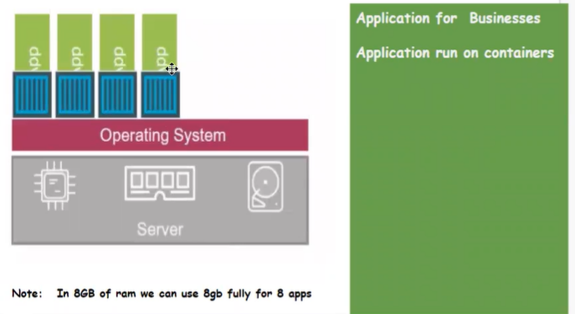

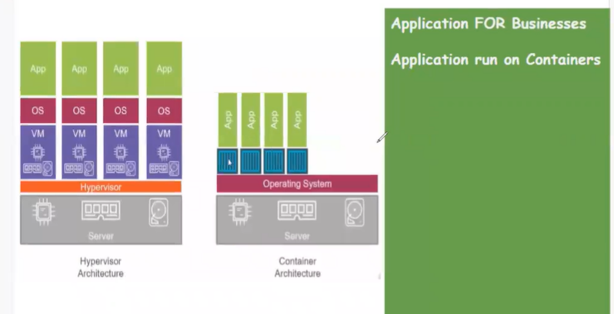

AWS

* CREATE A DOCKER HOST INSTANCES
* Git bash in desktop

$ sudo -i

# apt-get update

# copy lint get.docker.com

# ls

# sh get.docker.sh

# docker –version

# docker ps (running containers)

# docker ps -a (stop or running containers)

# docker images (showing images)

# docker run (we can able to create a containers)

# docker run --name myc1 -d -p 8081:80 nginx

# docker images

# docker ps

How to create container

# docker inspect<container name/id>

 (information)

# docker rm -f < container name/id> (delete container)



# docker rmi < container name/id> (delete image )



Same container create new image

# docker run --name myc2 -d -p 8082:80 nginx

# docker run –name myc3 -d -p 8083:8080 jenkins:2.60.3

# docker ps -a -q (only showing container ids)

# docker images -q (only showing images ids)

# docker rm $(docker ps -a -q) -f (delete all containers same time)

# docker rmi $(docker images -q) (delete all images same time)

APRIL 13 CLASS

Create aws instances

Install a dockers

Search in google link docker install commands

<https://docs.docker.com/engine/install/ubuntu/>

first uninstall any old version :

# sudo apt-get remove docker docker-engine docker.io containerd runc

# sudo apt-get update

# sudo apt-get install ca-certificates curl gnupg

Or

# sudo apt-get install \

ca-certificates \

curl \

gnupg \

Isb-release

# curl -fsSL https://download.docker.com/linux/ubuntu/gpg | sudo gpg --dearmor -o /etc/apt/keyrings/docker.gpg

# echo \

"deb [arch="$(dpkg --print-architecture)" signed-by=/etc/apt/keyrings/docker.gpg] https://download.docker.com/linux/ubuntu \

"$(. /etc/os-release && echo "$VERSION_CODENAME")" stable" | \

sudo tee /etc/apt/sources.list.d/docker.list > /dev/null

# sudo apt-get update

# sudo apt-get install docker-ce docker-ce-cli containerd.io docker-buildx-plugin docker-compose-plugin

Complete installation.

Topic Docker run

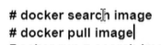



# docker search nginx

# docker pull nginx

# docker run -d nginx



# docker rmi -f nginx: latest [image delete command]

# docker rm awse123 -f [container delete command]

Docker architecture

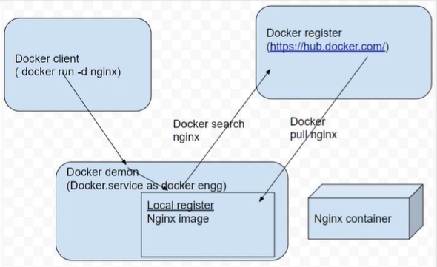

Docker life cycle

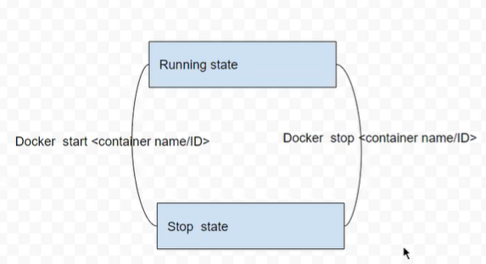

# docker start <container name/id>

# docker stop <container name/id>

Docker Modes

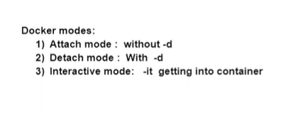

APRIL 14 CLASS



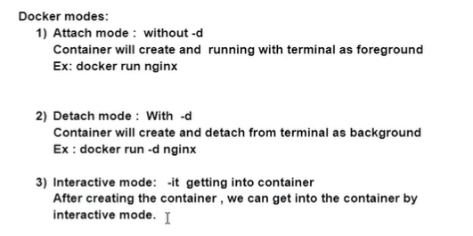

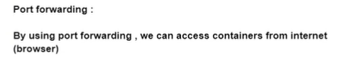

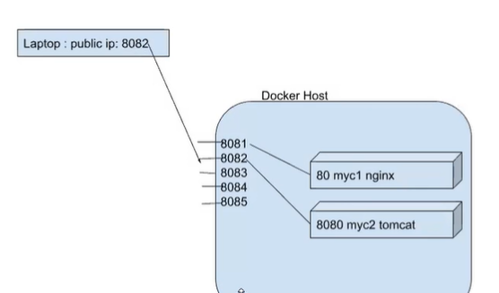

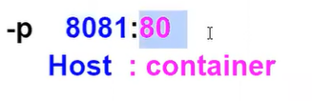

# docker exec -it [name id] /bin /bash (open container )

:/#

:/# exit (going out)

APRIL 15 CLASS

How container work

Create a instance with all traffic

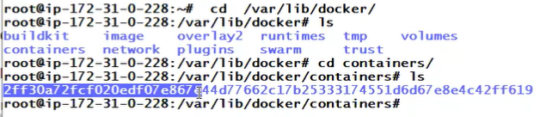

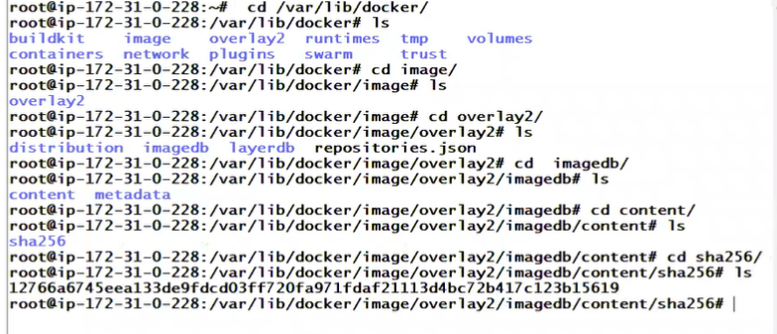

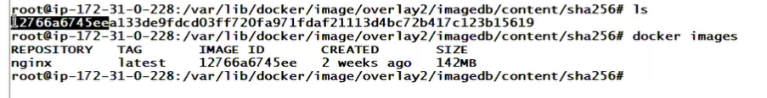

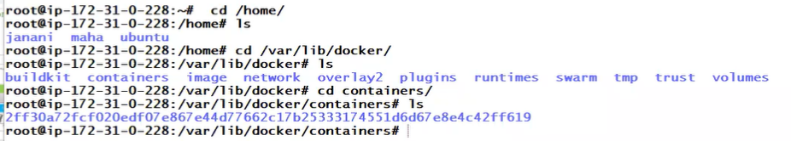



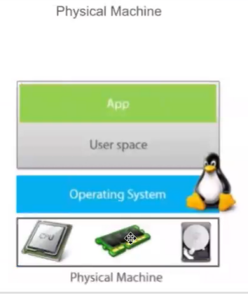

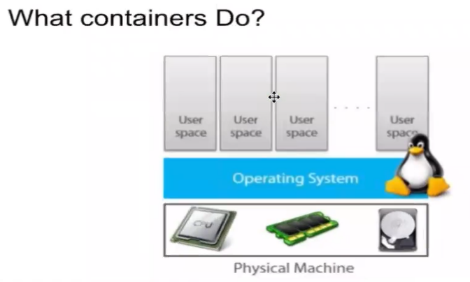

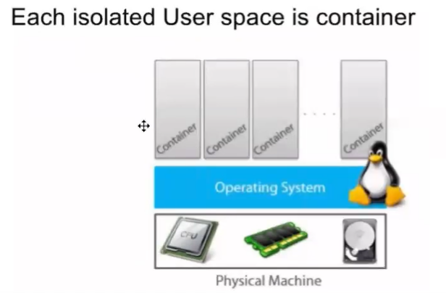

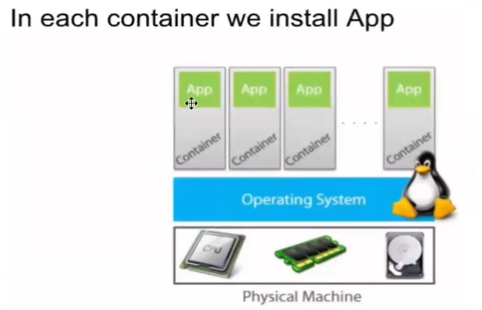

Inside container

 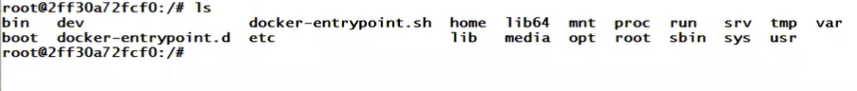

Inside Linux operating system

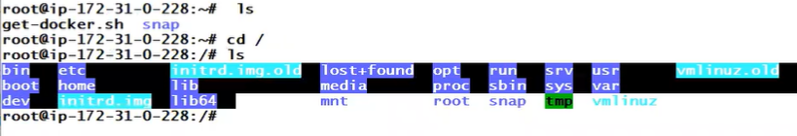

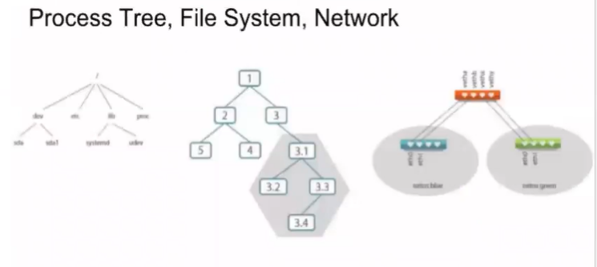

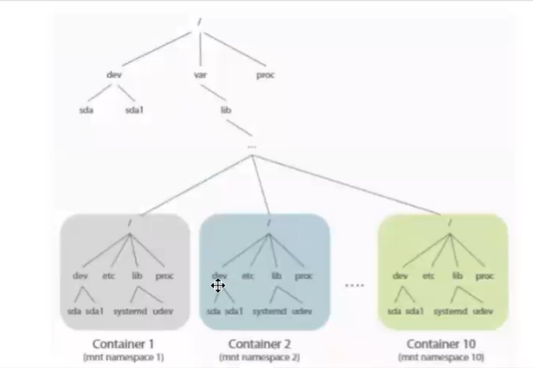

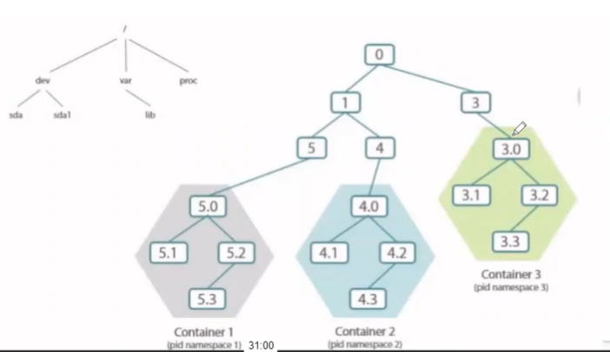

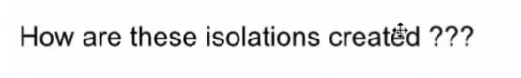

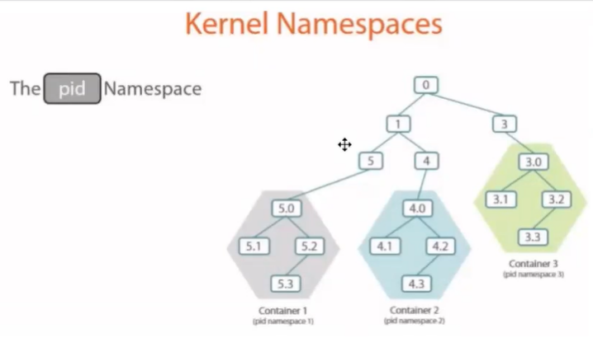

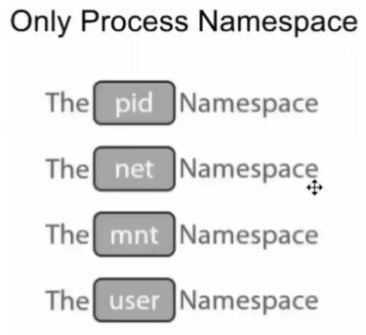

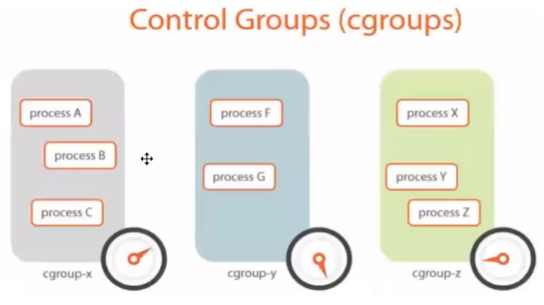

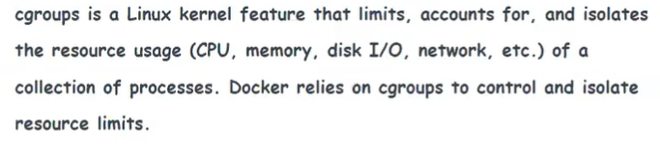

APRIL 19 CLASS

Tomcats install in container

<https://hub.docker.com/_/tomcat>

location 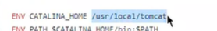

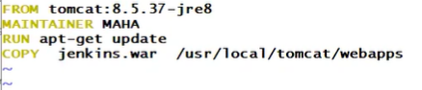

Download Jenkins.oi

Copy Generic java packages (copy)

Mydocker# wge (pest )

Expose and CMD is continues run Jenkins container

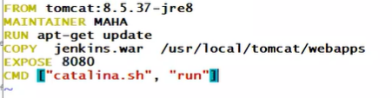

Image install



Container install



Inside docker file (vi edit another way to install Jenkins with inter net)

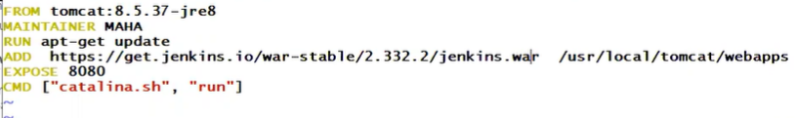

APRIL 20 CLASS

How upload image in hub.Docker.com

Create a account in hub.docker.com

Login hub.docker.com

# docker login

User id :

Password :

Login success

Create a image



Push in dockers



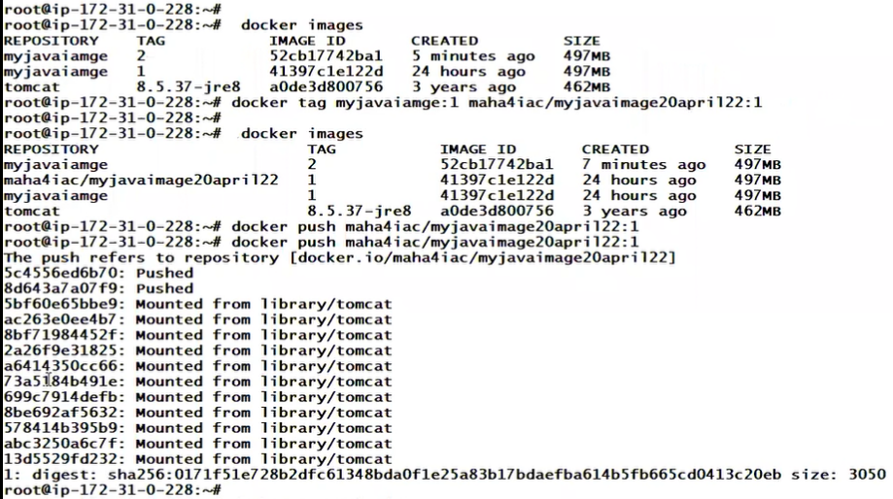

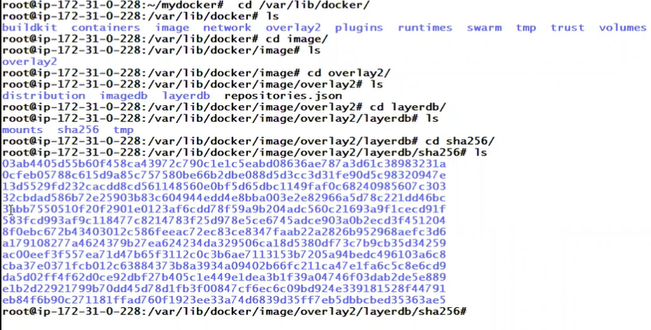

Enter to container command



Next topic VOLUME

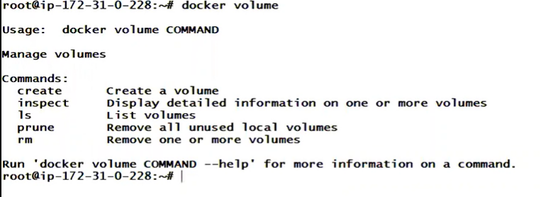



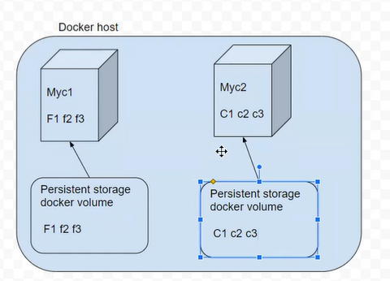

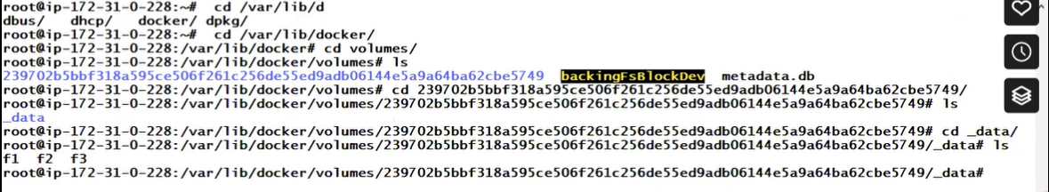

APRIL 21 CLASS

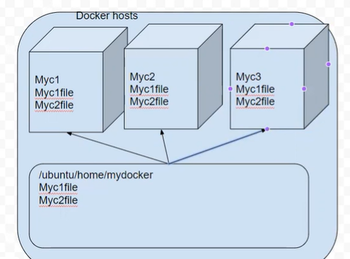









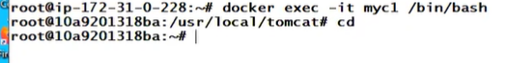

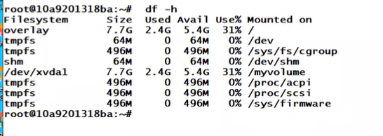

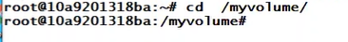

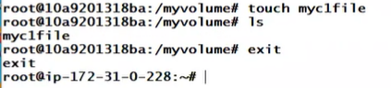

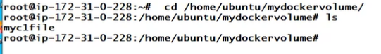





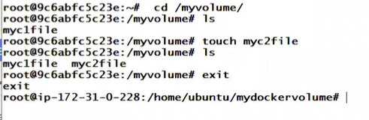

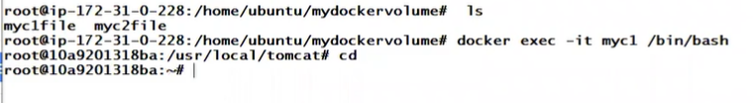

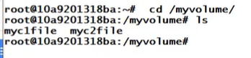

NETWORK

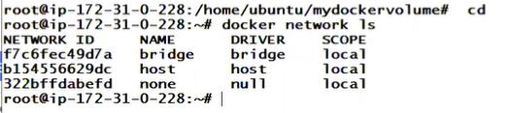











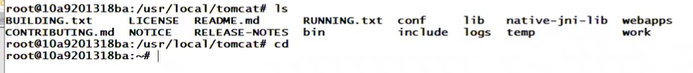

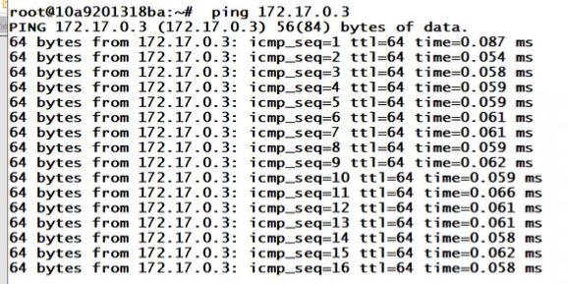

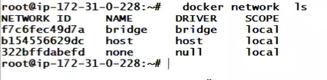

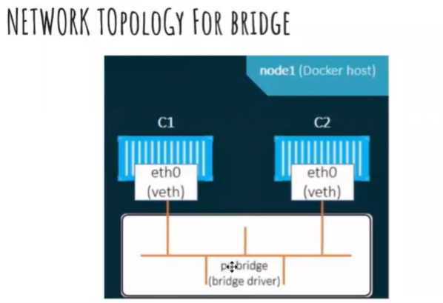



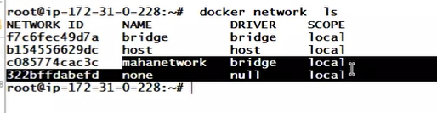



Create a 2 networks (2 id’s)

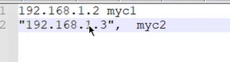

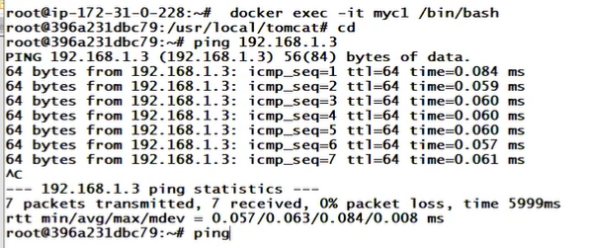

APRIL 22 CLASS

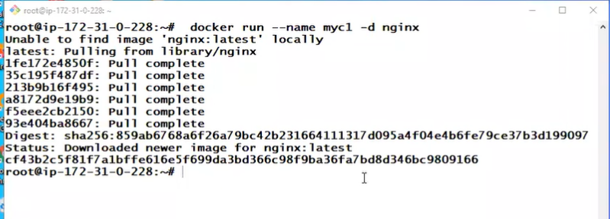



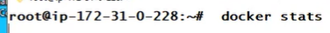





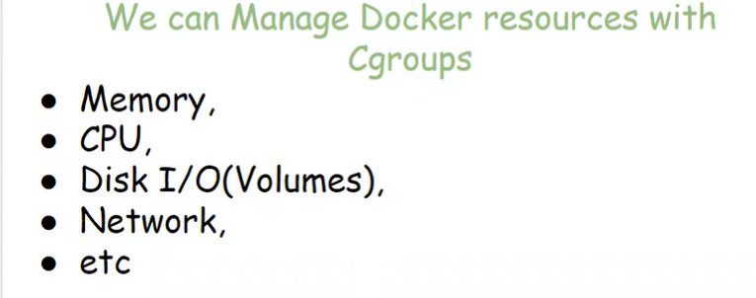

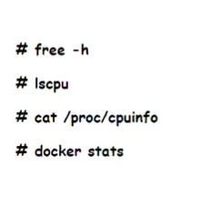

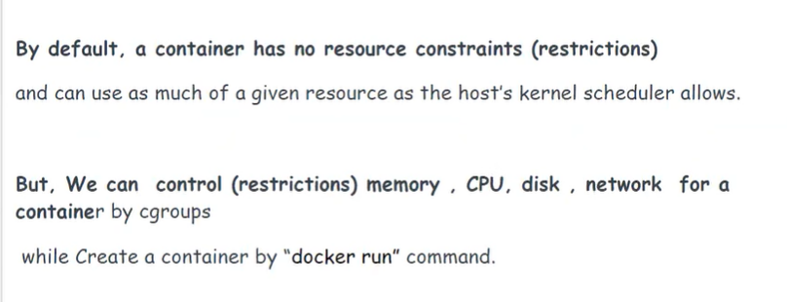

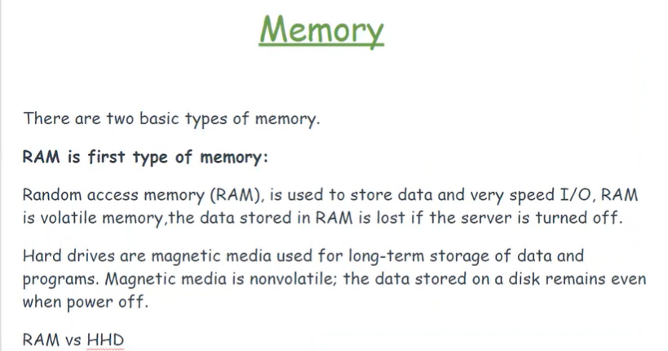

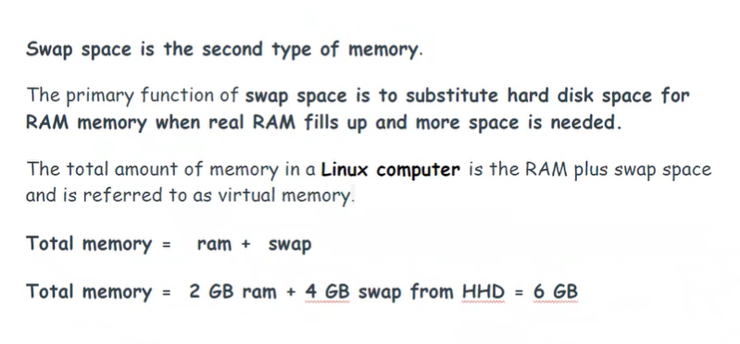

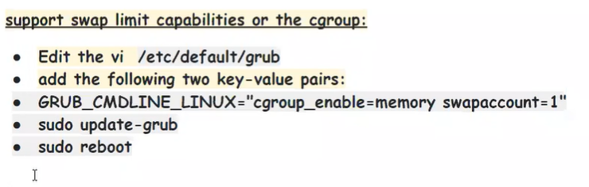



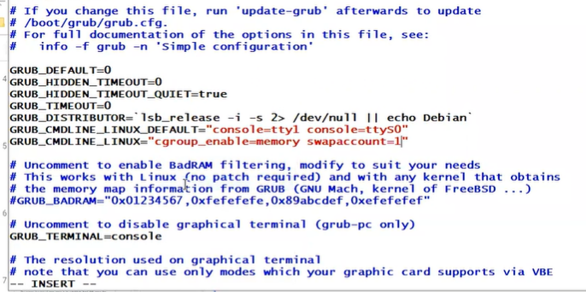

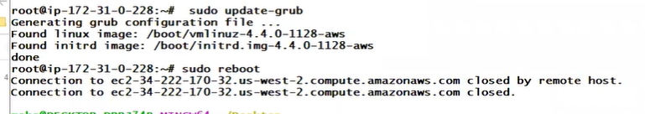

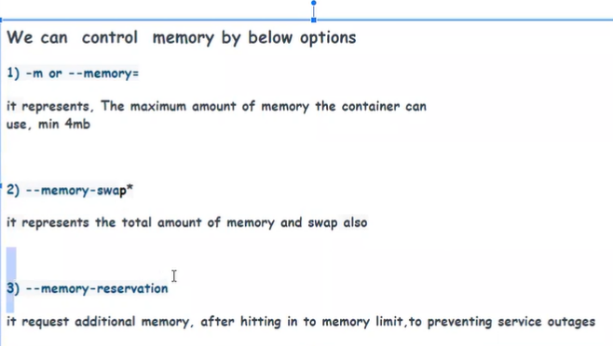

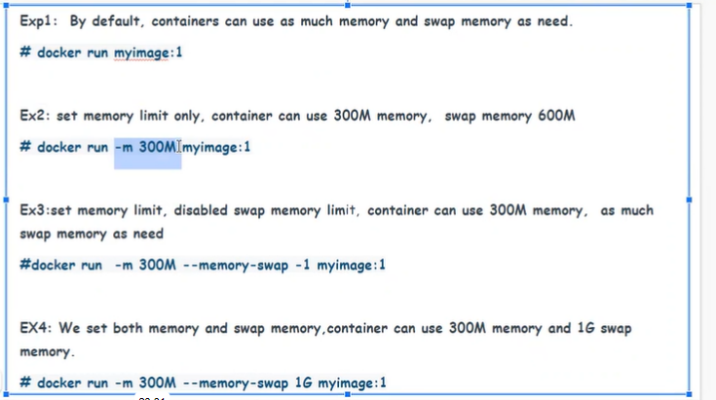

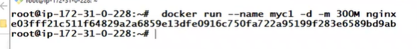

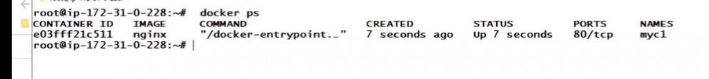

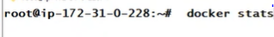



Snap mem0ry created default 600

Create a snap h0w mush y0u want



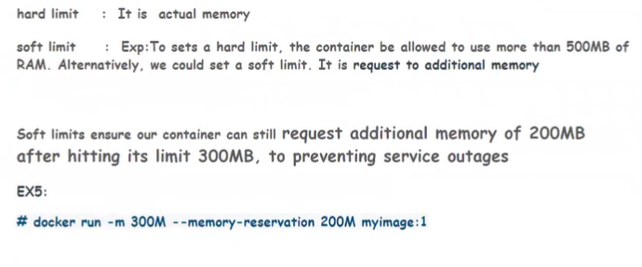

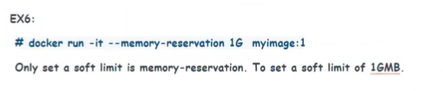



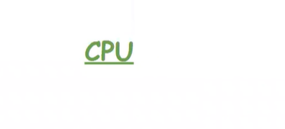

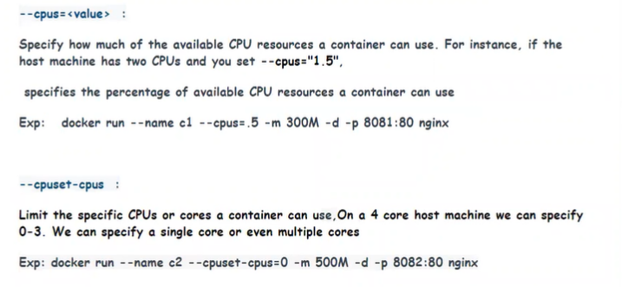

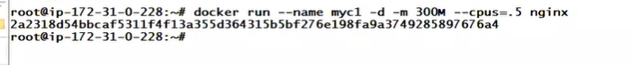

# D0cker stat



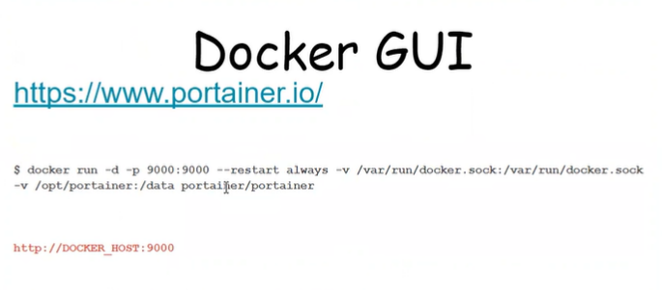

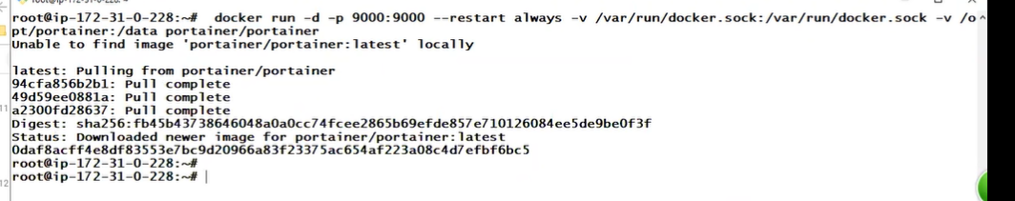

Ip :9000

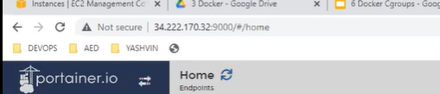

Create aa user id passwd :

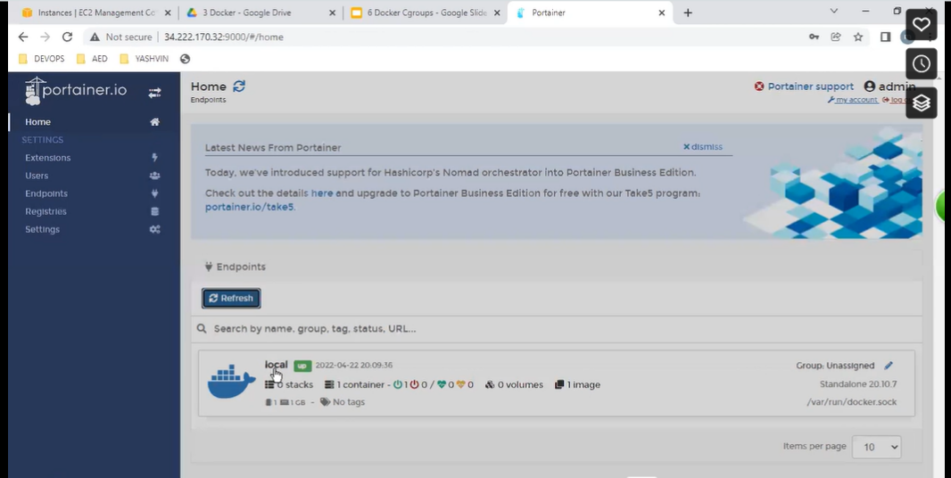

Visually we create a all containers

**MENU**

# sudo systemctl docker status (check docker status)

# docker pull nginx (image full command)

# docker run --name

# docker image ls (check image)

# docker PS -a -q